
Music proposal – Laurel and James – 19 December 2020
Your wedding is an intimate reflection of you and as such requires musical and creative attention. To authentically convey that feeling to the guests sharing in this momentous day, your musical input is invaluable.
Over the next months, we’ll be working with you on your wedding soundtrack. Building on our experience of what works and what doesn’t, we’ll guide you in the repertoire selection process from guest arrivals to closing song.
Most of the suggested acts below are open to learning new repertoire, so if you’ve got something specific in mind, let us know. While we’ll try to our best to accommodate you, we’ll also be honest when we feel something won’t work musically or is not possible.
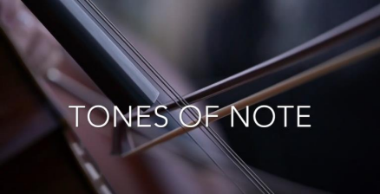
Guest arrivals: Starting at the Winchester Mansions in Sea Point, the celebratory sound of Il Afro Suns marimba band will entertain guests while they have a drink before boarding the shuttles for Babylonstoren.
African singer Mapumba Cilombo welcomes guests as they arrive at Babylonstoren. Performing as a solo or in a trio, Mapumba is a multi-genre world music artist who blends traditional melodies, stories, and languages from his native DRC with original inspirations that deliver a rich, authentic African sound with a modern touch.
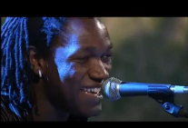
Best described as an African Tracy Chapman meets
Salif Keita, Mapumba’s versatility to take listeners on a
journey from soul and folk music through reggae, R&B,
funk and Afro-pop, combined with his infectious energy
and stage presence make his shows an unforgettable
kaleidoscope of experiences that linger long after the
concerts end. Mapumba’s music also carries messages
promoting peaceful, just and thriving communities, with
conscious lyrics.
Ceremony: Reflecting the intimate family ceremony you envision, we suggest keeping the entertainment here minimal by featuring a small ensemble including one or two vocalists with powerful voices.
For the flowergirls’ processional, for which we discussed using Bruno Mars' Marry You, we could slow the song down slightly, without losing its upbeat energy, and then using the ensemble musicians build up to the moment Laurel approaches the aisle.
For this song, we suggest using a vocalist like Ethan Florus. Reinterpreting and performing a wide range of songs from Drake’s Hot Line Bling to Alicia Key’s If I Ain’t Got You, Ethan Florus brings warmth and soul to his performances in a refreshing way.
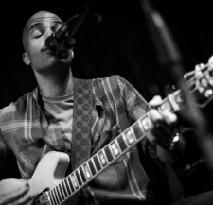
As discussed, instead of including hymns in the ceremony, we could include a musical interlude while Laurel and James exchange their vows. The music for this interlude should be instrumental so as not to distract from the words spoken during this time. A Whiter Shader of Pale by Procol Harum came up as one of the processional options but could easily be adapted to an instrumental version for the exchange of vows. If we go this route, we can stick closely to the original as referenced here or change it up by using a more classical arrangement, referenced here.
Lastly, in line with the Subway film reference - It's Only Mystery - Arthur Simms - that came up during our meeting, we could create a mashup between this track and Jimmy Cliff’s I Can See Clearly Now, using it as the recessional/confetti song once the ceremony has been concluded.
The style of both these songs ties in The Rivertones, the reggae band that we suggest using during pre-drinks.
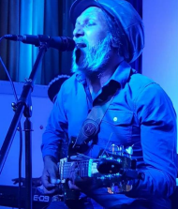
Pre-drinks: Building on the emotion created at the
ceremony, this period allows guests to catch up with
friends and family while taking in their surroundings. The
music during this time should animate and enliven those
conversations not interfere or compete with them. With
that in mind, we suggest taking a more relaxed, friendly
approach with the pre-drinks entertainment, featuring The
Rivertones during this set.
Led by vocalist and guitarist Roland Geoffrey Nair, The
Rivertones delight audiences with their upbeat, joyful,
eclectic, old-school reggae sound and have become Cape
Town's most loved reggae band, performing regularly at
venues and festivals across the city.

Dinner: A DJ is a good alternative to a live performer for dinner, with the music during this period setting the tone for the rest of the night. Musically speaking, DJs have a broader range of styles and songs to choose from, allowing them to take the music where the guests want it to go. Ultimately this set must be upbeat, featuring songs that appeal to the majority of your guests while also representing your musical preferences.
This is achieved by playing a mix of classics from soul, jazz, and current popular music. To find out which songs from those genres most resonate, we’ve included a 90-minute sampler below. Please give it a listen and send us your feedback. We’ll use that to curate the set.
Rus Nerwich - Playlist Sampler
Dance: Vocalists Nathan Ambach and Francesca Biancoli lead this 8-piece band including keys, bass, guitar, saxophone, trumpet and drums to perform high-energy dance set opening the dancefloor. Touring and performing together for the last 6 years, Rus Nerwich and Nathan Ambach (N8N) have developed an electric onstage chemistry, offering clients an all-inclusive musical solution.
Both Nathan and Rus bring together 20 years of musical and performance experience. From world-class live performances of quintessential classics covering soul, funk, blues, pop and jazz to a dance till you can’t dance no more DJ set, you are guaranteed one of the greatest parties of your life!
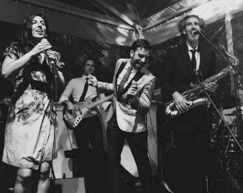
For more videos of the band’s past performances, please see the following links:
Instagram - Starlight Band - Prince - Kiss
Instagram - Starlight Band - Prince - Kiss (2)

Party: Straight from the band’s last song, we transition into the party set which will feature one of the following DJs.
Option one: DJ Colin Sher
An experienced and versatile DJ, Colin has performed at many of Cape Town's top clubs and parties. Some notable highlights include being the official DJ for the Coca-Cola pre-game events in Cape Town during the 2010 Soccer World Cup and performing at Trinity for the official U2, Coldplay and Kings of Leon afterparties. He’s also been a resident and guest DJ at many clubs in Cape Town over the years, such as St Yves, Tiger Tiger, Trinity, La Roi, Affinity, 91, The Grand and many more.
DJ Colin Sher - Promo video
DJ Colin Sher ft. Jimmy Nevis
Option two: DJ Nathan Ambach
In 2006, in his hometown of Antwerp, Nathan launched the nightlife series: The Love Below as ‘Your Monthly Rendezvous with Soul’, where he is still the resident DJ + promoter of funky music worldwide!
He’s DJ’d alongside Mark Ronson at the WMC in Miami and played at the Love Below with DJ Jazzy Jeff (The Fresh Prince), DJ Premier, DJ Maseo (De La Soul), and DJ Rashida – the official tour DJ of Prince and Bruno Mars and DJ'd sets in clubs and events around Europe, America, Asia, Africa and the Middle East.
His Spotify playlists and online mixtapes represent his funky style, championing soulful music with great grooves and party hooks. For over 20 years, N8N has been rocking the business from BBQs to Bar-Mitzvahs!
N8N - The DJ Side of the Story

